Revelations Report Writer

________________________________________________________

Technical Support (218) 236-1899
Fax (218) 236-0235
Sales (800) 596-4266

Copyright
Manual copyright © 1994 - 2002 Icon Systems, Inc. Printed in U.S.A. All rights reserved. This document may not, in whole or in any part, be copied, photocopied, reproduced, translated, transmitted or reduced to any electronic medium or machine-readable form without prior consent, in writing, from Icon Systems, Inc..
Warranty
Icon Systems, Inc. warrants that upon delivery, the software will substantially conform to the documentation for it, provided it is properly used on the computer hardware and with the operating system for which it was designed. Icon Systems, Inc. also warrants that the software will be properly copied onto the diskettes and that the diskettes on which the program is recorded will be free from defects in materials and workmanship under normal use and service for 60 days from the date the software is delivered to you. If you have properly registered your copy of this program any defective diskettes or documentation or substantial non-conformities between the software and its documentation will be corrected at no charge, provided you return the item and a copy of the paid receipt for it to Icon Systems, or an authorized dealer within 60 days after the delivery. Your only remedy in the event of a defect in the program, documentation or diskettes or for breach of any warranty is repair or replacement of the item as provided above.
ICON SYSTEMS, INC. DISCLAIMS ALL OTHER WARRANTIES OF ANY KIND REGARDING THE SOFTWARE, DOCUMENTATION AND DISKETTES, INCLUDING THE WARRANTIES OF MERCHANTABILITY AND FITNESS FOR A PARTICULAR PURPOSE.
Limitation of Liability
Neither Icon Systems nor anyone else who has been involved in the creation, production or delivery of this software or its accompanying documentation shall be liable for any indirect, incidental, special, exemplary or consequential damages, including but not limited to any loss of anticipated revenue, profit or benefits, resulting from the use of the software or its documentation or arising out of any breach of warranty. Icon Systems cumulative liability to you or any other party for damages for any cause whatsoever will be limited to the price you paid for the Icon Systems product that caused the damages.

Table of Contents
Revelations Report Writer 5
Report Writer Help Document 5
Using Revelations 5
Report Definition 5
Report Layout 5
Report Output 5
Appendix 6
Using Revelations 7
Registration 7
Accessing Report Writer 9
To Modify an existing report 9
To Copy an existing report 10
To create a New report 10
Table Definitions 10
Report Definition 14
Report Definition > Tables 16
Report Definition > Sort 18
Report Definition > Restrict 21
Report Layout 25
Command Line – Layout 25
Header/Footer/Body Sizing 26
Report Layout > Report Options 26
Report Field Options 26
Report Drawing Options 27
Report Section Options 27
Report Layout > Header/Footer Sections 28
Report Layout > Tools Palette 31
Report Layout > Calculated Fields 33
Report Layout > Functions 35
Calculated Field Functions 35
Report Output 38
The Print Request 38
Appendix 41
Appendix > Reports Described 41
Household Reports 41
Member Reports 42
Talents 45
Groups 45
General Attendance 48
Finance 49
Labels and Name Tags 52
Appendix > Glossary of table field names 53
Field Types 53
Index 63

Revelations Report Writer

Report Writer Help Document

Using Revelations
Registration Accessing Report Writer
Table Definitions

Report Definition
Report Definition Joining Tables
Sorting a Report Record Restrictions

Report Layout
Report Layout Tools Options
Headers & Footers Toolbox Palette
Calculated Fields Functions for Calculated Fields

Report Output
Screen - Printer - Files

Appendix
Reports Described Tables (Files) Defined
Detailed Table Definitions

Using Revelations

Registration
To begin using the report writer, you must first register the product. To register the Revelations Report Writer, follow the steps outlined in the following graphic.
Example
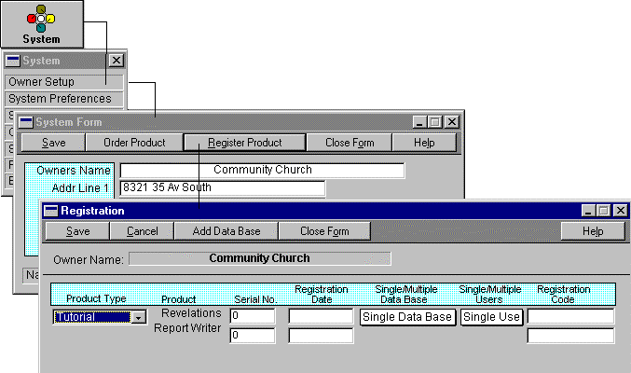

On the Registration window, you are prompted for a Serial No, Registration Date and Registration Code. This information is required by Revelations security to access the report writer. To obtain the Serial No. and Registration Code, call Revelations support at the phone number listed on the front page of this manual.

Upon successful registration of the Revelations Report Writer, a report write icon will appear on the top menu bar to the right of the icon labeled ‘Desktop Apps’. Note that the Report Writer module is NOT a multi-user module. If you are on a network, only one person can be in the Report Writer and no one will be allowed to run reports from within Revelations.

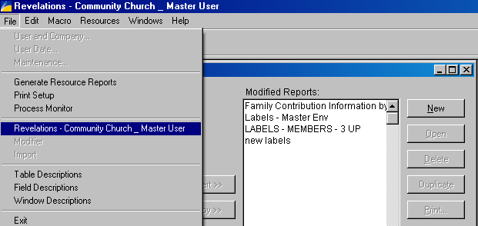

To return to Revelations when in the Report Writer, click on File on the top menu bar and select Revelations from the drop-down list of options.

Accessing Report Writer
The Revelations Report Writer allows you to modify existing reports that are part of the original package or to create new reports. Modified reports carry the original name of the report and are run in place of the original report when called. New reports are added to the ‘Modified Reports’ option located under the Reports option on the top menu bar.
Report Creation/Modification Checklist
- Select File → Report Writer” from the Revelations command line or press the Report Writer Icon on the top menu bar
- Select the Reports” button from the Toolbar
- A copy of this help manual can be accessed by selecting ‘Help’ and then ‘Contents’ from the top menu bar in the Report Writer.
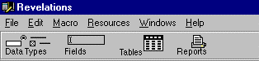
A modified report has the same name as the original report, consequently, when you run the report in Revelations the modified report is run in place of the original report.
A copied report has a different name from the original report and can be run when in the Report Writer module or when in Revelations from the Modified Reports option located under Reports.

To Modify an existing report
- Click to select a name from the Original Reports list and Insert (using the Insert button) into the Modified Reports list
- Click to select a name from the Modified Reports list
- Click the Open button

To Copy an existing report
- Select a report from the Original Reports list and copy (using the Copy button) into the Modified Reports list.
- Enter the New Report name
- Select the new report from the Modified Reports list
- Click the Open button
Note: An existing report from the Original Reports list can NOT be copied if its main file is a Temporary file. Temporary files are created when the report is run from within Revelations, consequently, the temporary file is not available when in the report writer. Since the file is not available the report isn’t valid for modification.

To create a New report
- Press the New button.

Table Definitions
All reports are prepared based on the information in one or more Tables. The table definitions in Revelations are available for viewing by pressing the Tables button located on the main window of the Report Writer.
The Table and Field descriptions are presented as a complete on-line reference and can be used to find two vital pieces of information.
- What tables and fields are defined in the Revelations software package
- How do the Revelations tables and fields relate to one another
You will probably notice that many tables contain the same name with some minor exception such as a version reference. Any table with a version reference can be ignored as old file versions are no longer available for access.

Below is an example of the Table Description window for Family Members. From this window you have access to its fields, index keys, and file relationships.
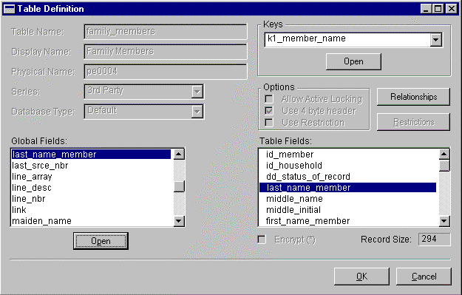

The fields in the right scroll window under Tables are the fields contained in the selected table. To view a field’s properties, locate the table field in the Globals scroll window and press the Open button. That opens the Field Definition window. Press the Open button and the Data Definition window opens. There you can view the fields attributes. You may notice if you look at drop down boxes that they may not contain any values. For example; Relationship. Yet when on the Member form in Revelations the field does contain values. The reason is that these values are loaded into the drop down box when the Member form is being loaded. The values are read in from a table which is maintained when you press the button Modify Drop Down on the System Preferences window. When a report is run that requires information from one of these files a file join occurs. More information on file joins is presented later in the manual. Following is a list of Drop Down fields and their related tables.
- Relationship dd_relationship
- Denomination dd_denom_status
- Language dd_language1
- Ethnic type dd_ethnic
- Household Status dd_hsehld_status (this field also applies to Family Member status)

A table can have one or many indexes. Indexes are used to order a table in different sequences for quick access. Using an index eliminates the need to pre-sort a table before viewing it in the desired sequence. To see the different sequences a table may be viewed, select an item from the Keys drop down box and press the Open button.

A table can have relationships defined with other tables. For example, a member record is associated with a household record. To see how this relationship is defined, press the button Relationships located on the Table Definition window. Select the Households table in the table relationships scroll window and press the Open button. There you will see that a member record is linked to a household record via the id_household field in the family member record. It is common to refer to record links as table joins. Both terms mean the same thing. Since the word join is more widely used future discussions in this manual will use join instead of link.

Report Definition
The Report Definition window is used to name the report, if new, and provide access to the various windows that make up its construction. If the report is a modified report than most of the fields on this form will be disabled.
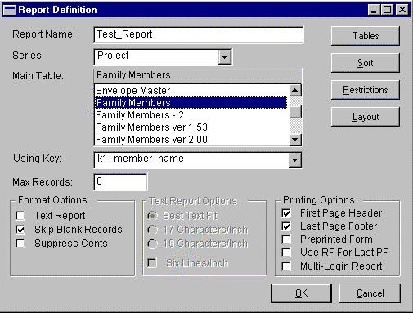

Assuming this is a new report.
- Name the report
- Give it a series id. The recommended series name is Project” or 3rd party”.
- Select your Main Table
- The Using Key” defines the sequence the records will be read. Records will be read in this sequence unless you define a sort sequence using the Sort button. To get an understanding of the fields which make up a key, press the Table button on the Report Writer window and then open the table shown above in the Main Table” scroll window. A complete definition of all Tables, their fields, index keys, and relationships to other tables are defined there.
Other Report Options
- Format Options
Text Report – When unchecked graphic reports are designed. Graphic reports can use multiple fonts, pictures can be added as well as color, any item can be moved one pixel at a time, etc. When checked, text reports are defined. Text reports run much faster than graphic reports but are less versatile.

Skip Blank Records – Tells the report writer to omit printing of any line when the body of the report does not contain any information.

- Text Report Options - This option list is available only when Text Report under Format Options is checked.
- Best Text Fit – The report writer automatically selects the font size based on the maximum number of characters that exist on one line. Choose this option to have the report printed using the largest printer font that will allow all of the information to be printed on the paper size and paper orientation specified for the printer to which the report will be sent.
- 17 Characters per inch - Choose this option to have the report print in compressed text format.
- 10 Characters/Inch - Choose this option to have the report print in uncompressed text format.
- Printing Options
- First Page Header - Choose this option if you want the page header to be printed on the first page of the report. If you don't want to print page headers on any page of the report, use the Report Section Options window to inactivate page headers. If page headers have been inactivated, the Page Header check box will appear dimmed.
- Last Page Footer - Choose this option if you want the page footer to print on the last page of the report. If you don't want to print page footers on any page of the report, use the Report Section Options window to inactivate page footers. If page footers have been inactivated, the Page Footer check box will appear dimmed.
- Preprinted Form - Select this option to remove the built-in margin from the layout area when designing a text report. With this option selected, you can place fields anywhere in the layout area. However, if you place fields outside of the printer's predefined margins, data outside of the margin will not print.
- Use RF for Last PF - Mark this option to replace the last page footer on the report with the report footer. The report footer will be printed in the area designated for the page footer. If you mark this selection, the page footer and report footer must be the same size, and both sections must be active. You should also mark the Last Page Footer option.

Report Definition > Tables
The Tables button allows the user to extend the list of tables included in the current report through relationships that exist between the Main Table and other Revelations data tables. An example would be to join the Attend Events table to the Attendance Records table.

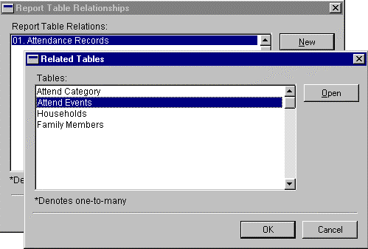
- Press the Tables button to include related tables to this report.
- Press the New button on the Report Table Relationships window
- Select the related table and press the OK button
- If many records are related to a table an asterisk will appear along side the table name and the table name will be indented. One example is: many Family Member records are related to a single Household record.
- More than one related table can be joined to the main table. Furthermore, once a joined table appears on the Report Table Relations window it can be selected and tables can be joined to it.

Report Definition > Sort
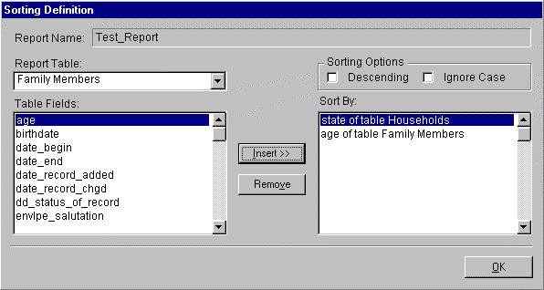
The Sort button on the Report Definition window allows the user to sort the report data. Sorting a report supercedes the index selected on the Report Definition window as the sequence the records are printed in. The Sort Segment window is displayed as the user clicks the Sort button.

On the Sort Definition window, the user defines the sorting hierarchy for the current report. To define the sort sequence, the user selects the tables from the Report Table drop down list and then the fields that define the sort order in top-down order (select the table/field that is the primary sort option first, and so on).

Below is an example of sorting a report by "state of table Households" and then "age of family member" within the state.
Note: Reports run faster when keys are used to sequence the report instead of sorting.
Resulting Data set:
Name Age State
Chris Carter 27 MN
Kirby Puckett 34 MN
Arnie Carlson 51 MN
Virgil Hill 27 ND
Lawrence Welk 80 ND
To define this sort sequence, we first select the primary sort state. To access the fields in the Households table, click on the table name Family Members. The drop down opens and Households can be selected. Now that the Households table is selected the household fields appear in the scroll window. Select the field state and press the Insert button. State moves to the top of the right scroll window titled Sort by.

Next we want to add the secondary sort field Age. When you press the Insert button the selected field is placed at the top of the right scroll window unless a field in that window is highlighted whereupon it is added following the highlighted field. Since this is what we want, select the field state of table Households in the Sort by scroll window.

"click"

Click on the table name Households in the left scroll window changing it to Family Members. Select the field age from the scroll window and press the Insert button. Age has now been added to the Sort by scroll window and was placed after the field "state of the table Households".

The sort is now completely defined. Click OK to return to the main Report Definition window.

Report Definition > Restrict
The Restrict button on the Report Definition window allows the user to restrict the data that is used in the report. When a user defines a restriction formula, every data record to be presented on the report is "screened" using the restriction formula. The screening process is defined by a comparison of the reporting data to the values defined in the restriction formula. The formula is reduced to a true or false answer. If the result of the restriction formula is "true", the data record is included in the report. If the value of the restriction formula is "false", the record is eliminated and the report writer continues with the next record.

The example below demonstrates the following restriction:: (age >= 18 AND age <= 55).

Data Record:
Age Name City State
18 Steve Sweeney Buxton ND
57 Bill Hanson Moorhead MN
40 Sean Frahe Minneapolis MN

Based on the restriction formula, the data for "Steve Sweeney" and "Sean Frahe" will be included in the report. The record for Bill Hanson will be rejected (skipped) because his age is 57 which is greater than 55. Below is the form used to enter a restriction.

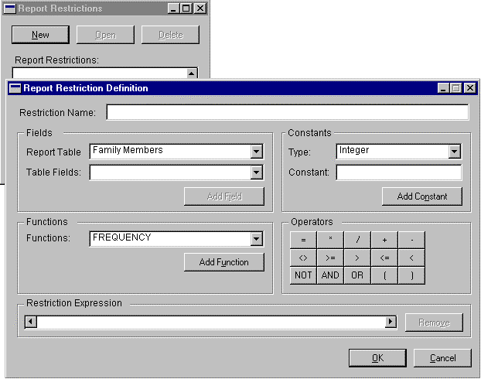

- Enter the name you want to give the restriction in the Restriction Name field.
- Define your Restriction Expression through the use of Table Fields, Constants, Functions and Operators
- To include the age” field in the Restriction Expression, select the table Family Members” from the Report Table drop down. Select age” from the Table Fields drop down and click on the Add Field button as shown in the graphic below.
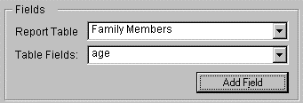
- Continue by selecting a logical operator to include in the Restriction Expression. In our example, the logical operator is greater than or equal to”. To add this operator, click on the button with the associated logical symbol.
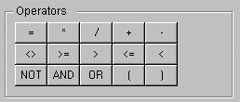
- To complete the first part of the Restriction Expression, we need to compare the value of "age" to some other field or constant. In this case, we wish to compare "age" to the constant of "18". To add "18" to the Restriction Expression, work through the following steps:
> Define Constant Types as Integer
> Type the value "18" in the Constant field
> Click the Add Constant button

Although this example gives a limited view of defining Restriction Expressions, the basic principles shown here can be used to build complex logical expressions. To expand beyond the basic equation provided here, include the following items as part of any expression:
Constant Types
The constant types drop-down list includes entries for Integer, Dollar, String, Date and Time data types.
Functions
The functions drop-down list includes a number of predefined functions for working with Revelations data. To include a function in the Restriction Expression, select the function from the drop-down list and click the Function button. All of the functions take a "field" as input and therefore, after selecting a function, you should proceed by selecting the field to be used with the selected function.

Editing the Restriction Expression
To adjust the contents of the Restriction Expression, you may reposition the "expression cursor" by clicking on any item in the expression. To insert an operator, function or some other item ahead of an expression item, just click on the item and proceed by selecting the item you wish to insert. To remove and item, click on the item to be removed and press the Remove button.
For a complete list of Functions, refer to the Report Layout > Functions

Report Layout
When the user selects the Layout button from the Report Definition window, the Report Layout window is displayed. This window provides the user with a cross-section of tools that will be used to define/alter the layout of the selected report.

Command Line – Layout
Layout > Grid
The Layout > Grid command line option ensures that all elements placed on the report align with the vertical and horizontal grid bars on the Report Layout window. Regardless of whether the grid is displayed, all elements are aligned to the grid. In the layout graphic shown below, the Grid option is selected (denoted by the check mark). When the Grid is not checked you can move fields up – down – left or right one pixel at a time. Generally, the grid should be unchecked only when graphics reports are defined.
Layout > Align Grid
The Align to Grid command is used to push” a selected report element to the nearest alignment mark. After selecting one of the report fields, select Align to Grid to align the field to the nearest x,y grid axis.
Layout > Show Grid
Use this option to display the alignment grid as part of the Report Layout window. The check mark denotes the presence or absence of the grid.
Layout > Grid to Back
This places the grid behind any fields
Layout > Send to Front/Send to Back
These commands are used interchangeably to change the viewing order of two overlapping fields. By selecting the top most field and selecting Send to Back results in the field being placed behind the field it was hiding.
Layout > Field Position & Size
The field position and size, for any selected field on the Report Layout window, is displayed in the lower left corner of the window.

Header/Footer/Body Sizing
Along the left hand side of the report is a dark gray strip containing the report section tags” for each section of the report. The letters in this column are abbreviations for the associated report section.
PH – Page Header RH – Report Header B – Body
PF – Page Footer RF – Report Footer
To adjust the size of these report sections, click and hold the section tab and move up or down to make the section smaller or larger. To add/modify/delete a report section, see the Tools > Report Section Options. You can add your own headers and footers in which case they will have a tag of AH1 for additional header 1 and AF1 for additional footer 1.

Report Layout > Report Options

Report Field Options
The Field Options selection is used to set the field characteristics for a selected report field. To use the Report Field Options command, select (by clicking) one of the report fields. Click on Tools > Report Field Options, and the system displays the Report Fields window. From the Report Fields window, you can modify the visible/invisible attribute for each field and can adjust the Field Type and Format to ensure proper display of the field. You can also hide each report field by setting the "hide when empty" attribute for the field.
The field types on the Report Fields window allow the user to calculate and report data that is not provided as part of the base system. The types provided in the Field Type scrolling list allow the user to calculate report averages, control totals, running sums, etc. For a more detailed description of the Field Types and their use in custom reporting, refer to the Field Types appendix.

Report Drawing Options
The Report Drawing Options window is used to change the display/print attributes of the data fields on the report. To access the drawing options click on Tools > Report Drawing Options. The Drawing Options window can be used to view information for any selected report field (field selection made by "clicking" on a report field). The attributes noted below are ways you have to alter the presentation of the report.
Font Color Font Style Object Color Alignment Patterns
When you are modifying a text report, the Report Drawing Options window is displayed with the majority of the window disabled. This is because the primary attributes for each report field have already been selected as part of the original Report Definition window. Colors, patterns, etc. can be assigned only to reports marked as Graphics” (Text is unchecked).

Report Section Options
The Report Window Options selection gives you access to the Report Options window. From this window, you can select the basic report sections for your report. To access the section options click on Tools > Report Section Options.

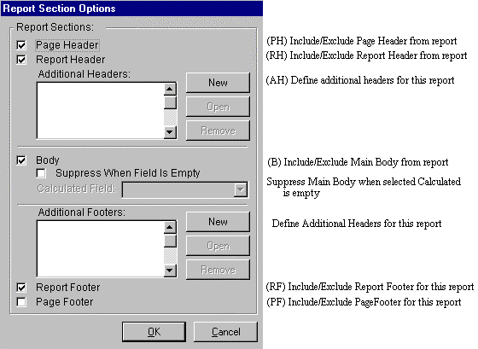

Report Layout > Header/Footer Sections
From the Report Section Options window, press the Add button to add additional headers or footers. Use this option to divide a report into various sections such as a Household section or a Group section. By clicking the Add button in the Additional Headers or Additional Footers section of the report, you can access the Header/Footer Options window (displayed below).
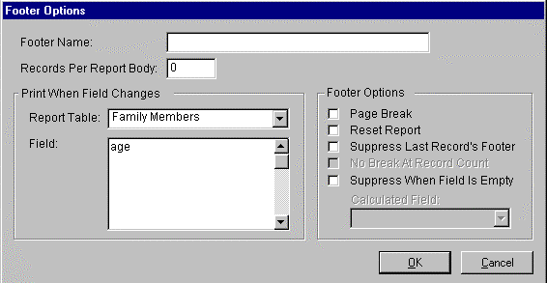

The Revelations Report Writer uses very simple logic to determine when an additional header/footer appears on the report. On the Header/Footer Options window, please note the question in the middle of the window:
"Print when what field changes?"
The drop-down window and associated list of data fields allows you to select a data field that will be used to trigger the generation of an additional header/footer. The information in this window is determined either by the file keys that are used when the report is built or by the sort keys you defined if you used the Sort” option.
As an example, if the Household table is selected in the Footer Options window and we want to perform a page break when the State changes we select the file Households then select the field, State and check the Page Break option.
The following Footer Options are defined:

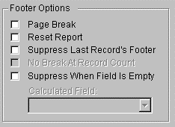

- The Page Break check-box is checked to request a new page whenever the Additional Footer is triggered.
- The Reset Report check-box is checked to request a report "restart" whenever the specified condition is matched. The Reset option includes starting over at page 1, beginning with the current record.
- When the Suppress Last Record's Footer check-box is selected, the report writer will not print the footer for the very last data record included in the report.
- The Suppress When Empty check-box allows the user to suppress report output when a selected Calculated Field is empty. The Calculated Fields available in the drop-down list box are defined as Calc Fields on the main report writer window.

Report Layout > Tools Palette
The Tools Palette resides on the Report Layout window and provides a wide variety of tools for use in report formatting. To use, select the desired tool with the left mouse button. Move your cursor into the report layout section of the window and click again with the left mouse button. To use the last 4 tools (line, ellipse, circle, square), move your cursor to the report layout, click and hold your left mouse button down and then drag the mouse to create the size object you want.
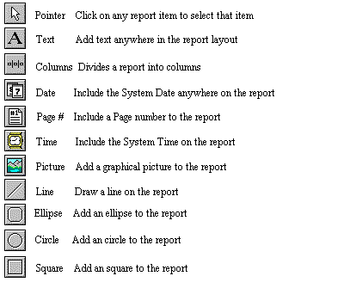
The Table & Field Selection function of the report writer allows the user to select fields from a table, select a global field, or to create a new calculated field.

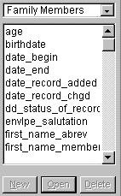
To select a field from a table
1 - Using the drop down box select the table that contains the field(s) you’re looking for
2 - Select the field using the scroll bar or press the first character of the field when the focus is in the scroll window. Also the up and down arrows can be used to move from one field to the next.
3 – Using the mouse drag the field to the report layout placing it in the desired report section.
4 – Once the field is on your layout use the mouse or the up and down arrow on your keypad to position the field where you want
System Variables: System Variables are data fields held in memory by Revelations while Revelations is running. These fields are only available to a report while it is being run in Revelations. For example a modified report.
To use a System Variable:
- Change the drop down box to System Variable
- Find and select the desired System Variable by using the scroll bar or by pressing the first character of the desired field
- Select the field using the mouse and drag it into the desired section of the Report Layout
- Once the field is in the desired layout section use the mouse or the up and down arrow on your keypad to position the field where you want.
Calculated Fields: Calculated fields are fields created by you for just this report.
To work with calculated fields
- Select Calculated Fields from the drop down box. Existing fields will show up in the scroll box.
- Select a field and press the Open button or press the New button to create a new one

Report Layout > Calculated Fields
A calculated expression can be used to accomplish a number of different reporting objectives, including:
- Conditional display of a data field based on a calculation or data value
- Calculation and display of a data value that is not stored in the Revelations table system
- Compound calculations where data the value of a calculated field is based on a cross-section of data tables and system variables
The screen below shows an example of creating a field called Pledge Fullment”. The "Pledge Fulfillment" field was calculated by dividing the "pledge amount" by the "pledge_amnt_posted". These values are selected (by clicking) from the "Pledge Commitments" table (select the Pledge Commitments table by clicking on the Resources switch until the "Pledge Commitments" table appears).

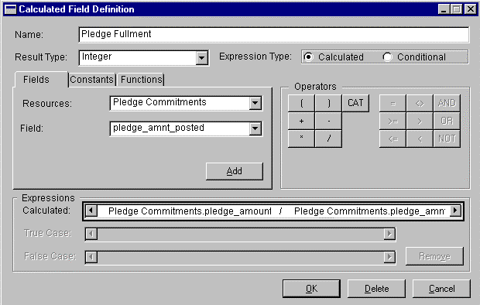

We generate the equation shown above by working through the following steps:
- Click on the "Calculated Expression" field (selects field for edit)
- Click on the "pledge_amount" field (selects field for placement)
- Click the Add button (adds pledge_amount to expression)
- Click the button (add division symbol to equation)
- Click on the "pledge_amnt_posted" field (selects field for placement)
- Click on the Add button (adds pledge_amnt_posted to expression)
With this calculated field now complete, press the OK button.
To create a Conditional Expression, select an Expression Type of Conditional. This will cause the True Case and False Case lines to appear at the bottom of the form. Enter a conditional expression into the Expressions Calculated line. Highlight the True Case by clicking anywhere in the line and enter the True Case Expression using the same techniques used for entering the Expression Calculation. Do the same for the False Case Expression.

Report Layout > Functions

Calculated Field Functions
CUR_STR | Converts the data type (control type) of the associated field from a "dollar" type to a "string" type
INT_STR | Converts the data type (control type) of the associated field from an "integer" type to a "string" type
LFT_STR | Prints the data preceding the first caret (^) in a string field. This function can be used to print a portion of a character string: (Ex: LFT_STR(Moorhead^MN^56560) = Moorhead)
LNG_STR | Converts the data type (control type) of the associated field from a "long integer" to a "string" type
POWER_10 | Raises the field value to the power of 10
RGT_STR | Prints the data succeeding the first caret (^) in a string field. This function can be used to print portions of a string variable (Ex: RGT_STR(Moorhead^MN^56560) = Moorhead^MN)
STR_DAT | Converts the data type (control type) of the associated field from a "string" type to a "date" type
STR_CUR | Converts the data type (control type) of the associated field from a "string" type to a "dollar" type
STR_LEN | Counts the number of characters (not including trailing blanks) in a field with type "string"
STR_LNG | Converts the data type (control type) of the associated field from a "string" to a "long integer"
STRIP | Strips trailing blanks from the end of a "string" field
SUBSTRING | The substring function works in the same manner as the WILDCARD function defined below. However, the SUBSTRING function is more flexible in the string patterns that can be "matched" since it will match substrings of a field rather than requiring the full contents of a field to match the specified argument.
UCASE | Converts (before printing) all characters in the associated "string" field to upper case
WILDCARD | Determines match/no-match status for a given "match argument" and a selected database field. The format of the wildcard function is WILDCARD(argument) = field. The wildcard function can only be used with "string" data types. The argument used as input to the WILDCARD function can include a (?) to match single characters and (*) to match multiple characters (Ex: WILDCARD(Lut*) = "Lutheran" is a true statement)

Report Output

The Print Request
Regardless of whether you are running Revelations or the Report Writer, you may request output at any time by pressing the Print button. When running Revelations, the Print button (when available) is located in the upper-left corner of each window. In the Report Writer, the Print button is also located at the top of the window, but can be used only in conjunction with a selected report from the "Modified Reports" list. If the print button is dimmed after the report is highlighted it must be printed from within Revelations since it is using a temporary file.
Print Dialog
When you click the Revelations Print button, the system responds with the following dialog box.
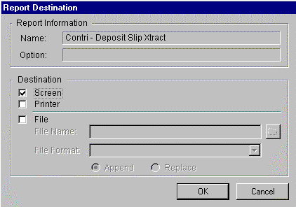

The Report Destination window allows you to select multiple output destinations. One of the features of Revelations is the systems ability to generate output in multiple locations - simultaneously. Due to this feature, you can select one or all of the check-boxes on the Report Destination window.
When File output is selected the following fields must be entered: a file name, a file format (use Comma delimited for word processors and Tab delimited for spreadsheets) and Append/Replace (normally you would select Replace to erase any existing data in the file).
With the entries on the Report Destination window complete, you may continue by clicking the OK button.
Screen Output
When you elect to send a report to your display, the Screen Output window is displayed with both report status information and the associated Revelations report. In the status line of this window, you can quickly view the status of the report along with the currently displayed page number.
If the right portion of the report is not visible, press the button. This will add a horizontal scroll button to the bottom of the report. Using this scroll bar you can view the right portion of the report.
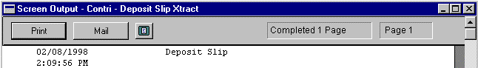

Revelations provides the unique feature of background report processing. We feel this is a key advantage to our customers since they are able to request a report and quickly move on to other computer tasks.
With the Windows operating system reports are always sent to the hard disk before being sent to the printer. This means that sufficient hard disk space must be available for a report to complete. If you find that your larger reports take an unusually long time to complete, check your free disk space. Annual Contribution Statements for a 600 household church could take 30 to 40 megabytes of disk space.

Appendix

Appendix > Reports Described

Household Reports
Household List
Provides a list of Households. Multiple status selections can be made. The Status Date to Use” is ignored when set to zero otherwise it lists only those households on or after the indicated date. Alternate addresses will be printed if active and switch is set to yes
Households with Email
Prints a list of all households having an email address
Household List with Members
This report is the same as the Household List except that the household members are included.
Households with Alt Addresses
Lists all households having an alternate address defined
Household Phone List
Prepare a phone list for one or more status selections. The report is printed in two columns to conserve paper. Caution: Printing this report to a disk file results in the second column to be lost
Hshld/Mem Edit Phones & Email
Lists all possible phones and emails with available space for writing in information.
Household Phones/Email All
Lists the all phones and email for each household with only entered information printed.
Church Directory 1,2,3,4
Four different formats for printing church directories exist. Try out a sample by using the Last Name” restrict option. Multiple status selections can be made. You can format your own church directory using your word processor by going to Reports / Labels & Name Tags and select Church Directory Merge.
Household Census
Prints a list of households, their members and their special events, groups, talents, etc.
Household Notes
Prints a list of households having notes attached.
Household Tally
Prints a count of households by status code.
Census Transfer
List all or partial information for the household and all its members depending on check boxes selected.

Member Reports
Member List
Provides a list of church members. Multiple status selections can be made. A specific relationship or all relationships can also be selected. The household address will be printed unless the Alternate Address is set to yes and the member addresses is active.
Anniversaries
Anniversaries can be selected for a last name range, by one or more status codes, and by date range. Setting the Ignore Year” to yes causes the year on your date range to be ignored. Go to Reports / Labels & Name Tags to obtain labels or to merge an anniversary list with your word processor.
Birthdays
This works the same as Anniversaries.
Member List
Provides a list of church members. Multiple status selections can be made. A specific relationship or all relationships can also be selected.
Member List with Address
Provides a list of church members. Multiple status selections can be made. A specific relationship or all relationships can also be selected. The household address will be printed unless the Alternate Address is set to yes and the member addresses is active.
Members with Email
Report of all members having an email address.
Member Email and Phone Short
Provides a list of members with their primary email addresses and phone number
Member Emails & Phones All
Provides a list of members with all their email addresses and phone numbers
Members with Alt Addresses
Lists all members but only displays an address for those with an alternate address on the member form
Members Missing Birthdays
Provides a list of all the members that do not have a birthday filled in on the Member Form
Member Tally
Provides a count of all members by status code for the last name range entered.
Special Events
Prints a report of members that had the selected special event occur within the date range specified.
Special Events Archived
Prints a report of archived members that had the selected special event occur within the date range specified.
Special Events Partial Dates
Prints a list of people with only partial dates on the system
Special Events – Missing
Provides a list of people that are missing date information for Special Events
General Statistics Report
This report appears only when the default denomination for your system is set to Roman Catholic. Enter the year for which you want the Congregational report printed. One or more status codes can be selected.
Member Census Transfer
Prints a detailed list of the Members information. This is primarily used when a member is transferring to a different church
Member Census Transfer w/ Notes
Similar to the Member Census Transfer report with the inclusion of notes.
Congregational Report
This report appears only when the default denomination for your system is set to Lutheran (ELCA). Enter the year for which you want the Congregational report printed. One or more status codes can be selected.

Talents
List of Talents
Prints a list of all the available talents
Members List for Talents
Print a list of every member that is assigned to at least one talent. All talents that a member is assigned to will print.
Talent List
Print a member list for the selected talent
Talent List for Entire Catg
Print a member list for every talent in the selected talent category.

Groups
Most of the report lists noted below can be prepared to merge with your word processor by going to Reports / Labels & Name Tags.
Attending Members to an Event
Prints a list of attending members to a selected event
Attendance Ratio
Prints a list of people that attended group events with a percentage of how often they attended.
Group Category Events by Date
Prints a list of events that have occurred over a date range
Group List – Members
Provides a list of members associated with a group
Group List for Catg – Members
Provides a list of members associated with an entire group category
Group List – Households
Provides a list of Households associated with a household group
Group List for Catg – Hseholds
Provides a list of members associated with an entire group category
Group List with Birthdates
Provides a list of members associated with a group and includes the birthdate field
Group List w/ Birth & Baptism
Provides a list of members associated with a group and includes the birthdate and baptism fields
Group List with Household Name
Provides a list of members associated with a group and includes the household name
List of Member Groups
Displays a list of available groups.
Member Groups with Email
Provides a list of members associated with a group and includes the email address
Member groups without Email
Displays a list of all the members of a group that do not have an email address
Members List with Groups
Prepares a list of all members assigned to a group. All groups a member is assigned to are listed.
Members who missed an Event
Displays a list of people that did not attend a particular event
One Name per Household
Displays a list of the households that are assigned to a member group. If more than one person from a household is assigned to the group there will still be only one line printed for that household.
Prepare Multi-Week Roll Call
Prepares a template for keeping a roll call sheet for a group
Prepare Roll Call to an Event
This report is prepared and given to the instructor as an aid for taking attendance to a group event.
Prepare Roll Call for Category
Prepares a template for keeping a roll call sheet for a group
Restricted Attendance Ratio
Allows you to print an attendance ration with a restriction of people in specific status codes

General Attendance
Attendance for Single Event
Provides a list of all attending members to a an event.
Attendance for All Events
Provides a list of all events and the members who attended each event
Absentee Report
Provides a list of all members who did not attend at least one of the events during the date range entered. One or more status codes can be selected. Members whose status code was not selected will not be tested.
Attendance Ratio
Print a report showing the attendance ratio of a member during the date range specified. You can select one or more status codes. A member must have attended at least one event to be included on this report. To find people who didn’t attend any event, run the Absentee Report.
Category Attendance by Date
Displays a ratio report based on the number of times people attended over a date range
Summary Attendance
Print a total of all members who attended each event for the date range specified as well as the summary total for each event.
Summary Attendance by Time
Print the summary total for each time slot defined for the selected Attendance Category. One line will be printed for each event in the date range.
Visual Tracking of Attendance
Prints a visual attendance report of all members for the last 10 events of the category selected. Select one or more of the status groups you want to review.

Finance
Batch Date Summary Report
Provides a summary of the number of dollars given to all the funds based on the date that was entered from the Contributions Batch” window.
Contributions Summary Report
Provides a summary of the number of dollars given to all the funds based on the date that was entered from the Enter Contributions” window.
Envelope Listing for a Fund
Prints a list of Households and members who have contributed or pledged to a fund. An envelope range can be specified to limit the printout.
Envelope List w/ Family ID’s
Provides a list of all people on the Envelope Maintenance window and their internal ID number.
Envelope Master Report
Provides a list of names and envelope numbers being used. More descriptive envelope reports are available on the Envelope Maintenance window.
Family Contribution Info
Provides pledge and contribution information for all funds over a date range. This report also allows you to restrict people by amount given and/or by amount pledged.
Family Contribution Summary
Prints a list of giving by household for the date range specified. Households that didn’t contribute are not included in the report.
Family Contribution by Fund
Prints a list of giving by household by fund for the date range specified. Households that didn’t contribute are not included in the report.
Family Contribution One Fund
Prints each contribution received for each envelope number for the selected fund for the date range specified.
Fund Comparison
Report that compares multiple funds over a given period of time. An example would be to compare what was given to the General Fund” of 2001 to the General Fund” of 2002 for the first quarter of the year
Fund List
Prints a list of Funds including the fund id. This report is used when setting up a relationship with Vanco Services in preparation for electronic contributions.
Period Comparison
Report that compares contribution and pledge information for all the funds over a given date range. An example would be to compare what was given to all the funds for the first quarter of 2002 to all the funds for the first quarter of 2001
Pledge/Contributions-One Fund
Provides pledge and contribution information for one specific fund.
Pledge/Contribution – All Funds
Provides pledge and contribution information for all funds over a date range. This report also allows you to restrict people by amount given and/or by amount pledged. This report is similar to the Family Contribution Info report with the exception that this report splits multiple giving units in a family to show what each of them is doing.
Pledge/Contribution Comparison
Prints a comparison of giving to pledges over a specified period of time. To be included on the report a pledge must be present. A one page summary can be printed for budgeting purposes.
Pledge/Contribution Fund Info
Provides pledge and contribution information for one fund over a date range. This report also allows you to restrict people by amount given and/or by amount pledged.
Pledge/Contribution Percentage
Prints a list of all envelopes, who they are assigned to, their pledge amount, contribution amount for the date specified and the percent of contribution. The report can be run for one or more status groups.
Posting Journal Reprints
Reprints one or more posting journals. The only difference is that the title of the report says it is a reprint. It is a good idea to print a Journal Reprint for any posting for which Reversing Entries were performed. Contribution transactions that were reversed will be noted on the Reprint.

Labels and Name Tags
Use Labels and Name Tags to print labels or to merge with your word processor. To use this screen make your selection from the scroll window, enter the label type parameters using the bottom half of the screen and define your output using the top right half of the screen.
If you want to merge information with your report writer, you must first prepare the data by pressing the Export File” button. Forgetting this process will result in the report writer working with old data. After pressing the Export File” button, wait for a message telling you the process is complete before activating the Direct Link button. The Direct Link button will link directly to either Microsoft Word or to Word Perfect, however, other word processors will work though it will require you to build the merge process.

Appendix > Glossary of table field names

Field Types
str – consist of printable characters 0-9, A-z, and grammar characters
int – integer in the range of plus or minus 32,768
lint – long integer
cur – currency
vs – visual switch
dd – drop down list
dte – date field
comp – a composite field made up of multiple fields.
cmbo – combo box, drop down list that can grow dynamically

Field Name Length Type Description
_________________________________________________________________
addr_ln1 40 str Address Line 1 for households and alternate address records
addr_ln2 30 str Address Line 2 for households and alternate address records
addr_zone 5 str Way to further classify households
age 3 int Age of a member. This is automatically calculated based on the birth date
attend_category_name 30 str Name of the general attendance category
attend_date 4 dte Date of a general attendance event
attend_name 30 str General attendance event name
attend_tracking 0 dd integer values are 1=Summary, 2=by Household, 3=by Member
[6]attend_time_of_day 60 str Array of 6 fields each 10 characters long
age_minimum 3 int Minimum age to use when displaying members for general attendance events
attend_family_totals 6 int Attendance total of families for a given general attendance event when tracked by household
attend_member totals 6 lint Attendance total of members for a given general attendance event when tracked by member
attend_summary_totals 6 lint Attendance total for all times for a given general attendance event
attend_tracking_times_vs 0 vs 1=yes,2=no denotes whether totals are tracked in summary or by attend_time_of_day.
batch_date_created 0 dte Date batch was created
batch_date_posting 0 dte Date the batch was posted
batch_dlrs_cks 11 cur total dollars for this batch received in the form of checks. Value is valid only when switch ‘Track check vs cash’ is on.
batch_dllrs_cash 11 cur total dollars for this batch received in the form of cash. Value is valid only when switch ‘Track check vs cash’ is on.
batch_last_trx_line_nbr 6 int Line number of last contribution entered
batch_last_trx_line_nbr_ext 6 int Used when a contribution is distributed across multiple funds
batch_marked_for_pstg 0 vs 1=Active, 2=Set to Post. Batches marked for posting do not appear in the contribution batch window.
batch_name 30 str Name of a contribution batch
batch_time_posting 0 time Time the batch was posted
batch_trx_nbr_of 4 int Total number of transactions entered for this batch
birthdate_string 8 str Allows for partial entry of a birth date
check_amnt 11 cur Contribution amount
[5]check_amnt_array 11 cur Array of 5 check amounts. Used to track the history of the last contribution.
carrier_rte 5 str Code issued by the US postal service
check_date 0 dte Date of contribution whether by check or by cash
check_nbr 6 lint Check number of a contribution when received by check
check_total 11 cur Total of contribution whether by check or by cash
checks_cash 0 vs 1=Check, 2=Cash
city 20 str
date_begin 4 dte Date the alternate address becomes effective
date_end 4 dte Date the alternate address ends
date_record_added 4 dte Date the record was added to the database
date_record_chgd 4 dte Date the database record was modified
dd_country 0 dd drop down list of country names
dd_visit_by 30 cmbo Values are determined by the customer
dd_visit_type 30 cmbo Values are determined by the customer
dd_status_of_record 0 dd 1=Active,2=Visitor,3=Inactive,4=Delete. These values are fixed, however, the customer may add to this list
email_addr 40 str Email address for a household or member
email_listed 0 vs 1=Listed,2=Unlisted
envlpe_salutation 40 str Name which appears on mailing labels
first_name_household 20 str First name of a household
first_name_member 20 str First name of a household member
fund_end_date 0 dte Date this fund becomes active
fund_end_date 0 dte Date this fund becomes inactive
fund_tax_flag 0 vs 1=No, 2=Yes Used to determine if this fund is tax exempt or not
group_category_name 30 str Name given to a group category
group_event_date 0 dte Date of a group event
group_desc 40 str Description given to a group
group_event_name 30 str Name given to a group event
group_id 6 lint A unique number assigned by the system to identify a group
id_attendee 6 lint Contains either an id_household value or id_member value depending on whether attend_tracking is by household or by member
id_attend_catg 6 lint A unique number assigned by the system to identify a general attendance category
id_attend_event 6 lint A unique number assigned by the system to identify an attendance category event
id_commit 6 lint A unique number assigned by the system to identify a Pledge Commitment record. One Pledge Commitment record is created for every household/member and for every fund that a contribution is made to.
[5]id_fund_array 6 lint Array of 5 fund id’s. Tracks fund(s) last given to which could be multiple funds if the contribution was distributed
id_group_category 6 lint A unique number assigned by the system to identify a group category
id_group_event 6 lint A unique number assigned by the system to identify a group event
id_household 6 lint A unique number assigned by the system to identify a household
id_member 6 lint A unique number assigned by the system to identify a household
id_pledge 6 lint A unique number assigned by the system to identify a fund
id_sched 6 lint A unique number assigned by the system to identify a particular scheduled event or misc event
id_sched_catg 6 lint A unique number assigned by the system to identify a scheduled event (used in Event Scheduling and misc scheduling)
id_sched_date 6 lint A unique number assigned by the system to identify a day of a scheduled event
id_srce_code 0 comp contains the value ‘jrnl’ plus a system assigned journal number
id_talent 6 lint A unique number assigned by the system to identify a talent
id_talent_category 6 lint A unique number assigned by the system to identify a talent category
id_visit 6 lint A unique number assigned by the system to identify a visitation record
ignore_yr 0 vs 1=Yes,2=No
Language_first 0 dd Values are determined by customer – system comes with default values
Language_second 0 dd Values are determined by customer – system comes with default values
last_batch_name 30 str Name of the last batch containing contributions to this fund
last_name_household 30 str Last name of a household
last_name_member 20 str Last name of a member
last_srce_nbr 6 lint Last journal number a contribution was posted to this fund by a household or member
maiden_name 20 str Wife’s maiden name
middle_initial 1 str Middle initial of a member
middle_name 20 str Middle name of a member
nationality 0 dd Values are determined by customer – system comes with default values
nick_name 20 str Preferred name of a member
phone_household 10 str formatted as (XXX) XXX-XXXX
phone_listed 0 vs 1 = Listed 2=Unlisted
phone_plus_ext 14 str formatted as (XXX) XXX-XXXX Ext XXXX
phone_work 14 str formatted as (XXX) XXX-XXXX Ext XXXX
pledge_acct 7 str Account number assigned to fund – used for reference only
pledge_amount 12 cur An amount pledged or tithed by the owner of this record – could be a household or a member
pledge_amnt_posted 12 cur Total amount of all contributions posted to this fund by a household or by a member
pledge_envelope_nbr 6 lint Envelope number assigned to a household or to a member. Zero is a valid number.
pledge_name 30 str Name of fund
pledge_nbr_of_commitments lint Total number of pledge commitment records assigned to this fund
pledge_period 0 vs 1=Week,2=Month,3=Quarter,4=Year,5=Other
pledge_end_date 0 dte Date that a pledge period ends
pledge_multiyr_flag 0 vs 1=No, 2=Yes Determines whether a fund can span multiple years
pledge_start_date 0 dte Date that a pledge period begins
pledge_year 4 int 4 digit year
pledge_yr_of_household 4 int 4 digit year – same as the pledge_year of the fund it represents
relationship 0 dd Values are determined by customer – system comes with default values
religion 0 dd Also referred to as denomination. Values are determined by customer – system comes with default values
q_major_acct 30 str Quicken or QuickBooks account that this fund belongs to
q_minor_acct 30 str Quicken or QuickBooks account that this fund belongs to
sched_catg_name 30 str Name of an event category in Event Scheduling
sched_desc 30 str A description of the scheduled event or scheduled misc item
sched_name 30 str Name of scheduled misc item
[5]se_by_whom 30 str Array of 5 special event user fields
[5]se_church 30 str Array of 5 church names
[5]se_date_string 30 str Array of 5 dates
[5]se_field6 30 str Array of 5 special event user fields
[5]se_field7 30 str Array of 5 special event user fields
[5]se_name 15 str Array of 5 special event names
sex 0 vs 1=Male,2=Female
state 3 str
talent_category_name 30 str Name of a talent category
talent_id 6 lint A unique number assigned by the system to identify a talent category
talent_name 30 str Name of a talent
text_field_notes 5000 txt Enter notes – up to 5000 characters
time_slot_end 2 int Value of 1 to 48 to determine which half hour the scheduled event ends
time_slot_start 2 int Value of 1 to 48 to determine which half hour the scheduled event begins
titled 13 str Title of a member or household
visit_directions 500 txt Used to hold directions belonging to a visitation event
visit_notes 5000 txt Holds any notes regarding a visitation
visit_summary 45 str Summary line describing the results of a visit
work_place 30 str Place where member can be found during the week days
zip code 11 str

Index

A
Accessing Report Writer 8
Additional Footers 27
Align to Grid 24
Appendix > Reports Described 39
C
Calculated Field 27
Calculated Fields 32
Church Directory 40
Compound calculations 32
Conditional Expression 34
Constant Types 22, 23
Contribution 48, 49, 50
Contributions 56, 57
D
Denomination 11
Drawing Options 26
drop down boxes 11
E
Envelope 47, 48
Ethnic type 11
F
False Case 34
Family Members 10
Field Definition 9
Field descriptions 9
Field Functions 34
Field Selection 30
File output 36
Finance 47
Functions 21, 23, 34
Funds 53, 55
G
General Attendance 46
Globals 9
Grid 24
Group Category 54, 55
Groups 40, 43, 45, 47, 49
H
hard disk space 38
Header/Footer 24
Header/Footer Sections 27
Household 39, 40, 41, 44, 45, 48
Household Status 11
Households 51
I
index keys 14
indexes 11
K
Key 14
L
Labels and Name Tags 50
Language 11
M
Member Reports 40
modified report 8
Modified Reports 36
Modify Drop Down 9
multi-user 7
N
New report 9
P
Page Break 29
Posting 49, 50
Print 36
R
Registration 6, 7
relationships 10, 11, 14
Report Definition 13
Report Definition > Restrict 20
Report Definition > Sort 17
Report Definition > Tables 15
Report Destination 37
Report Layout 24, 25
Report Layout > Calculated Fields 32
Report Layout > Functions 34
Report Layout > Header/Footer Section 27
Report Layout > Report Options 25
Report Layout > Tools Palette 30
Report Output 36
Report Section 26
Report Writer Help Document 5
Reports Described 39
Resources 32
Restrict 20
Restriction Expression 21, 23
S
Screen Output 36
Show Grid 24
Sort 17, 18, 19
Suppress Last Record's Footer 27
T
table definitions 9
Table Definitions 9
Tables 15, 16, 17
Talents 40, 43
temporary file 36
the related table 16
Tools Palette 30
True Case 34

